(Approx. 1480 words)

Raspberry Pi
By Dick Maybach, Member, Brookdale Computer Users’ Group, NJ
September 2017 issue, BUG Bytes
www.bcug.com
n2nd (at) att.net

I introduced the Arduino in my August 2017 article (available at http://www.bcug.com), and this month I’ll do the same for the Raspberry Pi. Although the two are both small, inexpensive, single-board devices designed to aid people to learn computer technology, they provide much different experiences. Using the Arduino is like visiting one of our national parks; while you will learn new things, you stay in a familiar environment. In particular, you work on your home computer using your present operating system. Using the Pi is more like touring a foreign country on your own; you are in a new environment with much to learn to become comfortable. In particular, you are using Linux on a completely new PC, and rather than just using applications, much of the time you will be configuring the system, often from the command line. While the rewards of mastering the Pi are greater, so is the effort required to achieve them.

The Raspberry Pi is a single-board computer requiring only a micro SD storage card, display, keyboard, and mouse for a complete desktop system. It normally runs under Linux, and the great majority of applications and activity are based on this operating system. (A smart-phone-like version of Windows has recently become available for it, https://developer.microsoft.com/en-us/windows/iot. Like Linux, it is free, but is far less capable than either Linux or Windows 10 and has far fewer applications and much less activity. However, the download is free, so experimenting with it costs nothing. In the remainder of this article, I'll discuss only the Pi running Linux.) When you enter the Raspberry Pi world, you go back in time to the PC scene of the 1980s. Instead of buying a complete computer, you get parts or kits and build what you want. Those who enjoyed that earlier time will be impressed with how much cheaper, smaller, and more capable the results are. The Pi is a complete computer with network access and applications that include office suites, complex mathematical analysis, graphics, and software design, and you can do anything with it that you now do on your PC. However, it's much slower, so such tasks as complex photographic manipulation aren't practical.

The Pi project began February 2012 with a single model, but in the years since, has evolved into a family, both from the original organization and independents. The Raspberry Pi organization produces the following models.
- The Pi Zero is the smallest lightest and cheapest. It's not suitable for use as a PC, but as a component. It features small size and low power consumption, but lacks the interface ports of the other models.
- The Pi 1 A+ is also intended for use as a component, although unlike the Zero it does have a full-sized USB and a HDMI port.
- The Pi 1 B+ includes several ports, including four USB, an HDMI, an Ethernet, and a multi-pin general-purpose one. This can function as a PC, although those below are considerably faster. It's been used for media centers, robotics, information displays, and in the International Space Station.
- The Pi 2 is similar to the 1 B+, but has a faster CPU. It's been used as a desktop PC, media center, web server, and gaming emulator.
- The Pi 3 is currently the most capable of the family, with the fastest clock speed, the most RAM, the best all-round feature set, including Wi-Fi and Bluetooth. It does consume more power, but it does make a credible PC, although one that is slower than current standards.

When you begin using a Raspberry Pi, you will need to equip it with a mouse, keyboard, and display, and this is surely how you should begin. Alternatively, you could connect it to your network and operate from your PC, which means the Pi doesn’t need a display, keyboard, or mouse. You control it either in command-line mode using the secure shell protocol (SSH) or using a remote desktop application to access the graphical interface. My experience is that getting these set up requires some experimentation, so you should wait until you become comfortable with the Pi before you try either. The Screen 1 shows the start of an SSH command-line session. It will look familiar to Linux users.

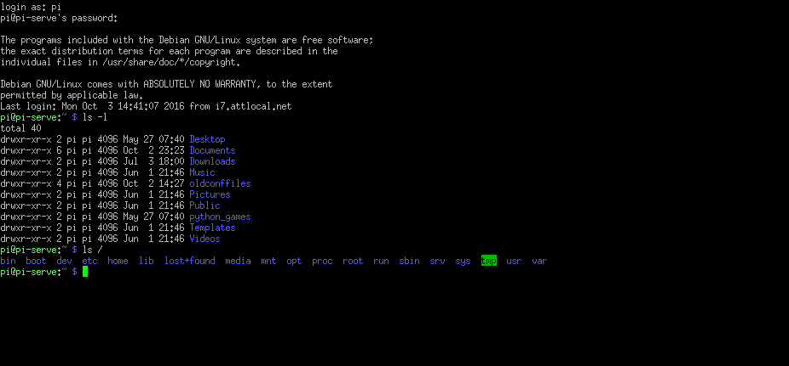
Screen 1. Controlling a Pi Over a Network Using SSH.

This is a window on my desktop PC; the Pi is across the room and connected by a LAN. Screen 2 is a remote-desktop window on my desktop PC showing the Pi's graphical interface, with three open applications, Web browser, file manager, task manager, and word processor. Normally, you wouldn't put this much load on such a small machine, but I did it here to make the point that it is a complete (although slow) PC.

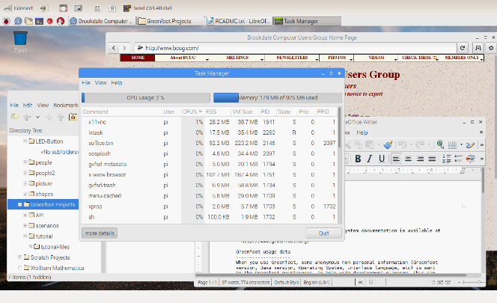
Screen 2. Controlling a Pi Over a Network Using a Remote Desktop.
The Raspberrian operating system, a variant of Linux available from the Raspberry organization, https://www.raspberrypi.org/, includes the symbolic mathematics program Wolfram Mathematica, https://www.wolfram.com/raspberry-pi/, which is similar to but more sophisticated than wxMaxima, discussed in the July 2017 issue of Bytes (available at http://www.bcug.com). Screen 3 shows three examples of its use, calculating a sum of integers, expanding an expression, and solving a set of three algebraic equations. There is much more to this tool, including plotting and Calculus.

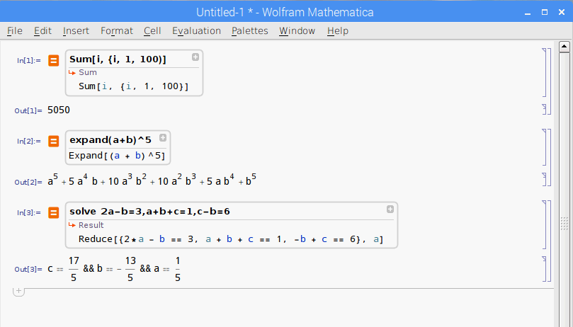
Screen 3. Wolfram Mathematica on a Pi.

Once you have a working PI, what might you do with it? Because it's separate from the PC with your tax returns, family photos, and other valuable data, you can use it as a sandbox where you can experiment without risk.
- Surf the Internet safely – if a rogue site does manage to install malware on the Pi, it is still isolated from your main PC. This makes it useful for guest use, especially for those fearless young people. You might even consider setting up a separate e-mail account, just for use while using the Pi, for use when a site demands an e-mail address before letting you have the information you need.
- Learn to Program -- The Pi runs on Linux, and one of that operating system's strong points is the wide variety of languages it supports, many with complete development environments. If you manage to make a horrible mistake, the damage is isolated. Consider Scratch if you just want a taste of what programming is or if you want to introduce a young person to it, or Python for a versatile, modern language but less complex than traditional ones, such a c. Python is well supported with many books and on-line communities.
- Build a Server -- The Pi's low cost, small size, and low power consumption make it well suited for server duty on your home network. A print server would allow you to share one printer with all your PCs. A file server would allow you to synchronize the contents of selected directories on PCs or would provide a single point for backups. A website server would provide an internal site for sharing information or would give you a place to learn website design. You could keep this simple (HTML only) or could add PHP support or even complete WordPress or Joomla services. Once the site is set up, you can remove its keyboard, mouse, and display. With any of these servers, you are also learning networking.
- Connect Hardware -- The Pi has a multi-pin interface to connect external hardware and many expansion boards to make this easier. (While Arduino expansion boards are called shields, those for the Pi are hats.) An Internet search will provide ideas for home control, Internet data collection, weather monitoring, and robotics. You probably don't want to use your home PC for such things, but again, the Pi's small cost, size, and power requirements open up these areas. And if a disaster does strike, you can replace your Pi for about $35.

You can make a Web search for more information, but do check the following.
- The official Raspberry Pi site is http://www.raspberrypi.org/. This is where you get software for it, read news about its development, see what members of its community are doing, and ask for help.
- A free monthly magazine, the MagPI is available at http://www.raspberrypi.org/magpi/. There are over 50 issues available for download, each with news and projects. A printed version is also available, but it's not free.
- There are many dealers for the Raspberry Pi, expansion cards, kits, accessories, books, and suggested experiments. Two popular ones are Adafruit, http://www.adafruit.com/, and Sparkfun, http://www.sparkfun.com/. You can have at least as much fun poking around these sites as we used to have at computer shows.
- Although the above dealers carry books, you can probably save money by buying them from on-line book dealers such as Amazon, and many large brick-and-mortar bookstores have several publications on the device.

